**Practical: 4**

**Aim: Explore enum.**

**Code:**

#[allow(dead_code)]

enum Payment {

Cash(f64),

Card(String, u8),

Crypto { currency: String, amount: f64 },

UPI(UpiData),

}

struct UpiData {

upi_id: String,

phone_number: String,

}

fn main() {

let payment = Payment::Card(String::from("Utsav Balar"), 12);

match payment {

Payment::Cash(amount) => println!("Cash Payment: {}", amount),

Payment::Card(name, amount) => {

println!("Card Owner: {}, Card Payment: {}", name, amount)

}

Payment::Crypto { currency, amount } => {

println!("Crypto Currency: {}, Amount: {}", currency, amount)

}

Payment::UPI(data) => println!(

"UPI ID: {}, Phone Number: {}",

data.upi_id, data.phone_number

),

}

}

**Output:**

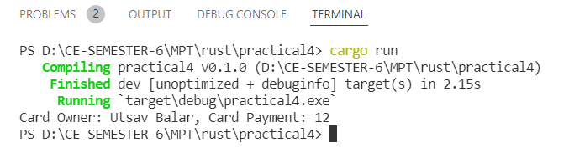

let payment = Payment::Crypto {

currency: String::from("Bitcoin"),

amount: 0.00000012,

};

Roman symbols using enum

**main.rs**

mod roman_symbols;

use roman_symbols::RomanSymbols;

fn main() {

let fifty = RomanSymbols::from_u16(50);

println!("{:?}", fifty);

use std::io;

let mut input = String::new();

println!("Enter a number: ");

io::stdin()

.read_line(&mut input)

.expect("Failed to read line");

let input = input.trim().parse().expect("Failed to parse input");

let mut num = String::new();

match RomanSymbols::int_to_roman(input) {

Some(value) => {

num = value;

println!("{}", &num)

}

None => println!("Invalid value"),

}

match RomanSymbols::roman_to_int(&num) {

Some(value) => println!("{}", value),

None => println!("Invalid value"),

}

}

**roman_symbols.rs**

pub static MAX: u16 = 3999;

#[derive(Debug, Clone)]

pub enum RomanSymbols {

I,

IV,

V,

IX,

X,

XL,

L,

XC,

C,

CD,

D,

CM,

M,

}

impl RomanSymbols {

pub fn value(&self) -> u16 {

match self {

RomanSymbols::I => 1,

RomanSymbols::IV => 4,

RomanSymbols::V => 5,

RomanSymbols::IX => 9,

RomanSymbols::X => 10,

RomanSymbols::XL => 40,

RomanSymbols::L => 50,

RomanSymbols::XC => 90,

RomanSymbols::C => 100,

RomanSymbols::CD => 400,

RomanSymbols::D => 500,

RomanSymbols::CM => 900,

RomanSymbols::M => 1000,

}

}

pub fn from_u16(value: u16) -> RomanSymbols {

match value {

1 => RomanSymbols::I,

4 => RomanSymbols::IV,

5 => RomanSymbols::V,

9 => RomanSymbols::IX,

10 => RomanSymbols::X,

40 => RomanSymbols::XL,

50 => RomanSymbols::L,

90 => RomanSymbols::XC,

100 => RomanSymbols::C,

400 => RomanSymbols::CD,

500 => RomanSymbols::D,

900 => RomanSymbols::CM,

1000 => RomanSymbols::M,

_ => panic!("Invalid value, {:?}", value),

}

}

pub fn from_str(value: &str) -> RomanSymbols {

match value {

"I" => RomanSymbols::I,

"IV" => RomanSymbols::IV,

"V" => RomanSymbols::V,

"IX" => RomanSymbols::IX,

"X" => RomanSymbols::X,

"XL" => RomanSymbols::XL,

"L" => RomanSymbols::L,

"XC" => RomanSymbols::XC,

"C" => RomanSymbols::C,

"CD" => RomanSymbols::CD,

"D" => RomanSymbols::D,

"CM" => RomanSymbols::CM,

"M" => RomanSymbols::M,

_ => panic!("Invalid value, {:?}", value),

}

}

pub fn symbols() -> Vec<String> {

vec![

"I".to_string(),

"IV".to_string(),

"V".to_string(),

"IX".to_string(),

"X".to_string(),

"XL".to_string(),

"L".to_string(),

"XC".to_string(),

"C".to_string(),

"CD".to_string(),

"D".to_string(),

"CM".to_string(),

"M".to_string(),

]

}

pub fn values() -> Vec<u16> {

vec![1, 4, 5, 9, 10, 40, 50, 90, 100, 400, 500, 900, 1000]

}

pub fn roman_to_int(value: &String) -> Option<u16> {

let (mut n, mut result) = (0, 0);

for i in value.chars().rev() {

let v = RomanSymbols::from_str(&i.to_string());

if v.value() >= n {

result += v.value();

} else {

result -= v.value();

}

n = v.value();

}

if result > MAX {

None

} else {

Some(result)

}

}

pub fn roman_pairs() -> Vec<(String, u16)> {

let symbols = RomanSymbols::symbols();

let values = RomanSymbols::values();

let mut result = Vec::new();

for (i, symbol) in symbols.iter().enumerate() {

result.push((symbol.to_string(), values[i]));

}

result.reverse();

result

}

pub fn int_to_roman(n: u16) -> Option<String> {

if n <= 0 || n > MAX {

panic!("Argument must be between 1 and 3999");

}

let mut result = String::new();

let mut n = n;

for (symbol, value) in RomanSymbols::roman_pairs() {

while n >= value {

n -= value;

result.push_str(symbol.as_str());

}

}

Some(result)

}

}

**Output:**

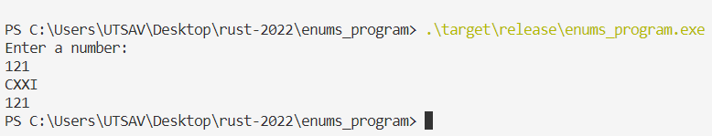

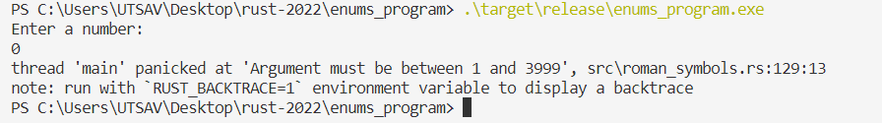

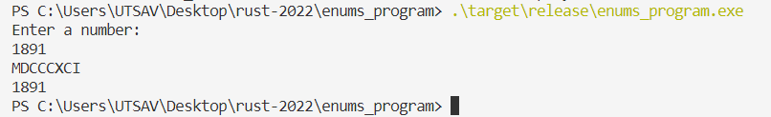

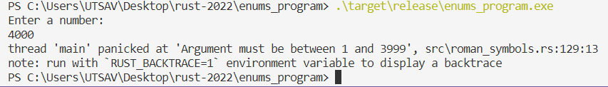

**Practical: 5**

**Aim: Explore packages and crates**

**Code:**

**Cargo.toml**

[package]

name = "modules_test"

version = "0.1.0"

edition = "2021"

# See more keys and their definitions at https://doc.rust-lang.org/cargo/reference/manifest.html

[lib]

name = "creature_library"

path = "./src/creature_library/lib.rs"

[dependencies]

rand_derive2 = "0.1.17"

rand = "0.8.5"

**bin/main.rs**

#[allow(unused_imports)]

use creature_library::creature::{Creature, Body};

use creature_library::get_type_creature::TypeToStr;

fn main() {

// let creature1 = Creature::Dog(Body {

// eyes: 2,

// nose: 1,

// hands: 0,

// legs: 4,

// mouth: 1,

// });

// let creature2 = Creature::Cat(Body {

// eyes: 2,

// nose: 1,

// hands: 0,

// legs: 4,

// mouth: 1,

// });

// println!("Creature 1 => {}", creature1.get_type_creature());

// println!("Creature 2 => {}", creature2.get_type_creature());

// creature1.creature_exists();

// creature2.creature_exists();

// let creature3 = Creature::new_creature(&Creature::Human(Body {

// hands: 2,

// legs: 2,

// mouth: 1,

// nose: 1,

// eyes: 2,

// }));

// println!("Creature 3 => {}", creature3.get_type_creature());

// let creature4 = Creature::copy_creature(&creature3);

// println!("Creature 4 => {}", creature4.get_type_creature());

// creature3.creature_exists();

// creature4.creature_exists();

// let creature5 = Creature::new_creature(&Creature::MythicalBeast(Body {

// hands: 8,

// legs: 8,

// mouth: 4,

// nose: 4,

// eyes: 8,

// }));

// creature5.creature_exists();

use std::io;

let your_creature: Creature = Creature::generate_random_creature();

let mut input = String::new();

println!("Enter your name: ");

io::stdin().read_line(&mut input).expect("Failed to read line");

println!("{} is the {}", input.trim(), your_creature.get_type_creature());

}

**creature_library/creature.rs**

// crate to generate random creature

use rand_derive2::RandGen;

// crate that implements method to get type of creature

use crate::get_type_creature::TypeToStr;

#[derive(RandGen)]

#[allow(dead_code)]

#[derive(Debug)]

pub struct Body {

pub eyes: u8,

pub nose: u8,

pub hands: u8,

pub legs: u8,

pub mouth: u8,

}

#[derive(RandGen)]

#[allow(dead_code)]

#[derive(Debug)]

pub enum Creature {

Dog(Body),

Cat(Body),

Human(Body),

MythicalBeast(Body),

Donkey(Body),

Monkey(Body),

Snake(Body),

Dragon(Body),

Fish(Body),

Bird(Body),

Lizard(Body),

Frog(Body),

Bat(Body),

Bear(Body),

Elephant(Body),

Rhino(Body),

Giraffe(Body),

}

impl Creature {

pub fn check_creature(&self) -> Option<bool> {

match self {

Creature::Dog(_)

| Creature::Cat(_)

| Creature::Human(_)

| Creature::MythicalBeast(_)

| Creature::Donkey(_)

| Creature::Monkey(_)

| Creature::Snake(_)

| Creature::Dragon(_)

| Creature::Fish(_)

| Creature::Bird(_)

| Creature::Lizard(_)

| Creature::Frog(_)

| Creature::Bat(_)

| Creature::Bear(_)

| Creature::Elephant(_)

| Creature::Rhino(_)

| Creature::Giraffe(_) => Some(true),

}

}

pub fn new_creature(&self) -> &Self {

self

}

pub fn copy_creature(&self) -> &Self {

Self::new_creature(&self)

}

pub fn generate_random_creature() -> Self {

Self::generate_random()

}

pub fn creature_exists(&self) {

match self.check_creature() {

Some(thing) => {

if thing == true {

println!("{} exists!", self.get_type_creature())

}

}

_ => {

println!("{} Doesn't exist", self.get_type_creature())

}

}

}

}

**creature_library/get_creature_type.rs**

use crate::creature::Creature;

pub trait TypeToStr {

fn get_type_creature(&self) -> &'static str;

}

impl TypeToStr for Creature {

fn get_type_creature(&self) -> &'static str {

match self {

Creature::Dog(_) => "Dog",

Creature::Cat(_) => "Cat",

Creature::Human(_) => "Human",

Creature::MythicalBeast(_) => "MythicalBeast",

Creature::Donkey(_) => "Donkey",

Creature::Monkey(_) => "Monkey",

Creature::Snake(_) => "Snake",

Creature::Dragon(_) => "Dragon",

Creature::Fish(_) => "Fish",

Creature::Bird(_) => "Bird",

Creature::Lizard(_) => "Lizard",

Creature::Frog(_) => "Frog",

Creature::Bat(_) => "Bat",

Creature::Bear(_) => "Bear",

Creature::Elephant(_) => "Elephant",

Creature::Rhino(_) => "Rhino",

Creature::Giraffe(_) => "Giraffe",

}

}

}

**creature_library/lib.rs**

pub mod creature;

pub mod get_type_creature;

**Output:**

